# Department of Computing

**CS344: Web Engineering**

**Class: BSCS – 5AB**

# Lab 1: HTML Introduction

**Date: Feb 15, 2017**

# Instructor: Dr. Asad Ali Shah

# Lab Engineer: Qasim Ali Khan

# Lab 1: HTML Introduction

Contents

Department of Computing 1

Lab 1: HTML Introduction 1

Instructor: Dr. Asad Ali Shah 1

Lab Engineer: Qasim Ali Khan 1

Lab 1: HTML Introduction 2

Lab 1: Introduction to DreamWeaver and HTML basics 3

Introduction 3

Objectives 3

Tools/Software Requirement 3

Description 3

Pitfalls 3

Deliverables 3

Getting Started with Dreamweaver CS6 4

The Welcome Screen of Dreamweaver CS6 4

The Dreamweaver Workspace 4

Understanding the Viewing Modes in the Dreamweaver 5

Creating a HTML document in DreamWeaver 6

Sample Code 6

Building a new Website and managing pages in root folder 6

HTML Introduction 9

What is HTML? 9

A Simple HTML Document 9

Example 9

Example Explained 10

HTML Tags 10

Web Browsers 10

HTML Page Structure 11

The <!DOCTYPE> Declaration 11

Write HTML Using Notepad or TextEdit 13

Step 1: Open Notepad (PC) 13

Step 1: Open TextEdit (Mac) 13

Step 2: Write Some HTML 14

Step 3: Save the HTML Page 14

Step 4: View the HTML Page in Your Browser 15

HTML Basic Examples 15

HTML Documents 15

Example 16

HTML Headings 16

Example 16

HTML Paragraphs 17

Example 17

HTML Links 17

Example 17

HTML Images 17

Example 18

HTML Elements 18

Nested HTML Elements 19

Example 19

Example Explained 19

Do Not Forget the End Tag 20

Example 20

HTML Attributes 21

The lang Attribute 21

The title Attribute 22

Example 22

The href Attribute 22

Example 22

Size Attributes 22

Example 23

The alt Attribute 23

Example 23

HTML Links - Hyperlinks 23

HTML Links - Syntax 24

Example 24

Local Links 24

Example 24

HTML Link Colors 25

Example 25

HTML Links - The target Attribute 25

Example 26

Example 26

HTML Links - Image as Link 26

Example 26

HTML Links - Create a Bookmark 26

Example 27

Example 27

External Paths 27

Example 27

Example 28

Example 28

HTML Images 28

JPG Images 28

GIF Images 29

PNG Images 29

Example 29

HTML Images Syntax 30

The alt Attribute 30

Example 30

HTML Screen Readers 30

Image Size - Width and Height 31

Example 31

Example 31

Width and Height, or Style? 31

Example 31

Images in Another Folder 32

Example 32

Images on Another Server 32

Example 33

Animated Images 33

Example 33

Using an Image as a Link 33

Example 33

Image Floating 34

Example 34

Image Maps 34

Example 35

HTML Tables 35

HTML Table Example 35

Defining an HTML Table 36

Example 36

HTML Table - Adding a Border 36

Example 37

HTML Table - Collapsed Borders 37

Example 37

HTML Table - Adding Cell Padding 37

Example 38

HTML Table - Left-align Headings 38

Example 38

HTML Table - Adding Border Spacing 38

Example 38

HTML Table - Cells that Span Many Columns 39

Example 39

HTML Table - Cells that Span Many Rows 39

Example 39

HTML Table - Adding a Caption 40

Example 40

A Special Style for One Table 41

Example 41

Now you can define a special style for this table: 41

And add more styles: 41

Frameset 42

Example 42

Definition and Usage 42

HTML Iframes 43

Iframe Syntax 43

Iframe - Set Height and Width 43

Example 43

Iframe - Remove the Border 43

Example 44

Example 44

Iframe - Target for a Link 44

Example 44

Lab Tasks 45

Task A 45

Lab Task B 46

Lab Task C 46

Lab Task D 47

# 

# Lab 1: Introduction to DreamWeaver and HTML basics

## Introduction

Purpose of this lab is to give you the overview about a web development tool Dreamweaver CS6. In this lab you will be able to understand the different features of Dreamweaver. Using the software the students will be able to develop basic HTML pages.

## Objectives

The objective of the lab is to provide a hands on experience on DreamWeaver and to allow students to develop basic HTML pages using the following elements

* Text
* Hyperlinks
* Tables
* Images
* Frames

## Tools/Software Requirement

The software includes Notepad / Notepad ++ and DreamWeaver

## Description

For creating webpages through HTML you will be required to follow the following steps.

* Open Notepad/Notepad++/DreamWeaver and start your HTML tags/code.
* Save your text file with .html extension.
* Double click the file saved and you will see your webpage in a browser.

## Pitfalls

* Any exceptions or errors leading to non-execution of submitted code.
* Failure to maintain scoring
* Failure to automate the enemies or respond correctly to the user input.

## Deliverables

Students will be evaluated between 0 and 10 and must upload the following on LMS:

1. Description of what was done in the task
2. Screenshots of the final output
3. Source code used

# Getting Started with Dreamweaver CS6

Dreamweaver CS6 is the ideal tool for building your website. Dreamweaver is a popular program among professional web designers, as well as people who want to build sites for their hobbies, clubs, families, and small businesses.

## The Welcome Screen of Dreamweaver CS6

The welcome screen is great starting point for creating content in the Dreamweaver CS6 by giving you access to several key features as shown in figure.

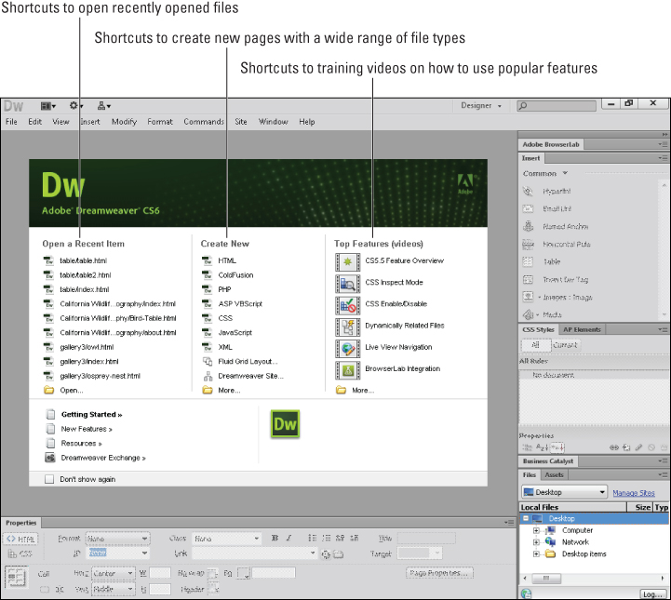

## The Dreamweaver Workspace

The Dreamweaver workspace is shown in the diagram. It contains all the panels and tool bars used to create the contents. So you can easily switch from workspace to another by using this tool.

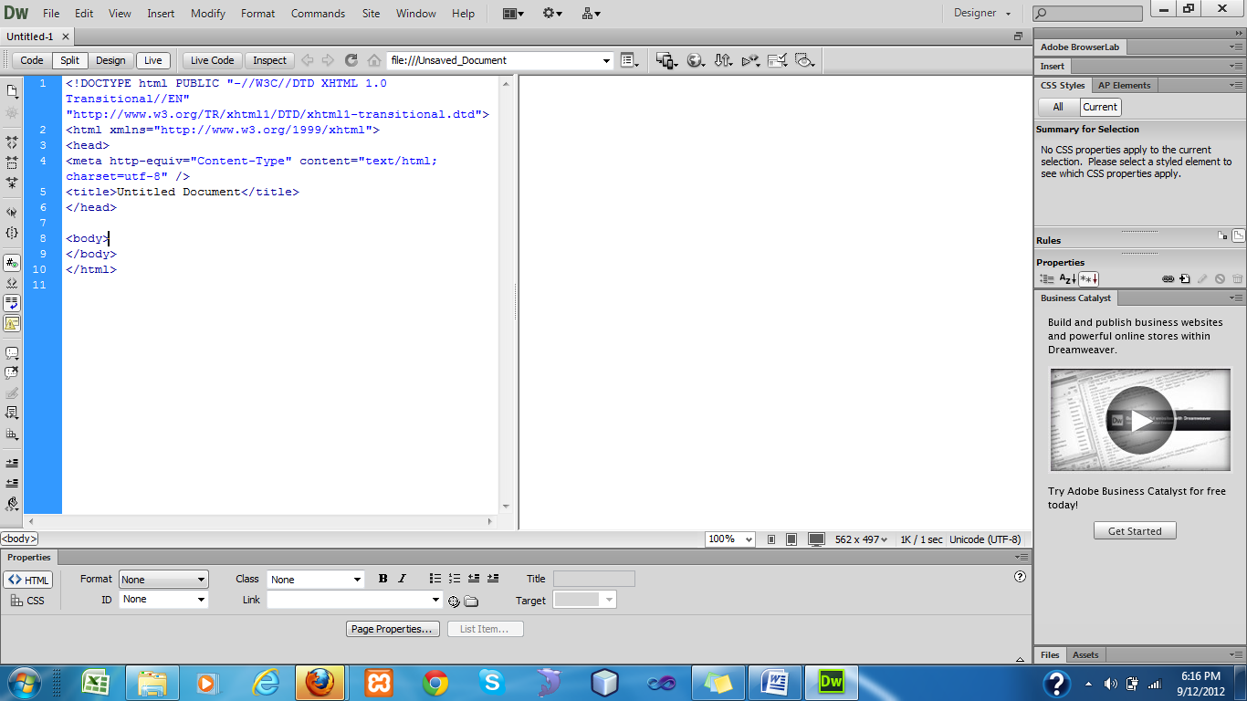

Dreamweaver support a number of workspaces so you can select a work space by selecting a design by clicking on **the** option highlighted in the figure.

## Understanding the Viewing Modes in the Dreamweaver

Dreamweaver has different view modes that’s helps you to see your web pages in different ways.

1. Create a new HTML page. Three different modes will be available to you **Code**, **Design**, **Split**.

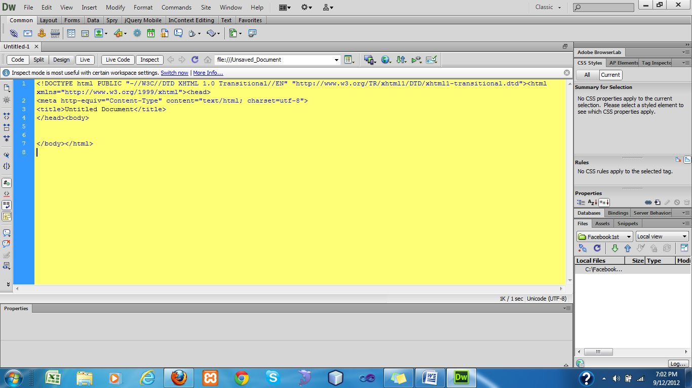

## Creating a HTML document in DreamWeaver

1. Create a HTML document.

2. Select the Design mode.

3. Type a line “I have started using Dreamweaver”.

4. Select **Heading 1 from** format menu**.**

5**.** Give a meaningful title **“My First HTML page”.**

6. Switch to Code view to see the changes.

7. Open Code view and put the following HTML code under the Body tag it.

### Sample Code

**<h1>Heading goes here...</h1>**

**<p>Enter your paragraph text here...</p>**

8. Click on the refresh Button as shown in the diagram below.

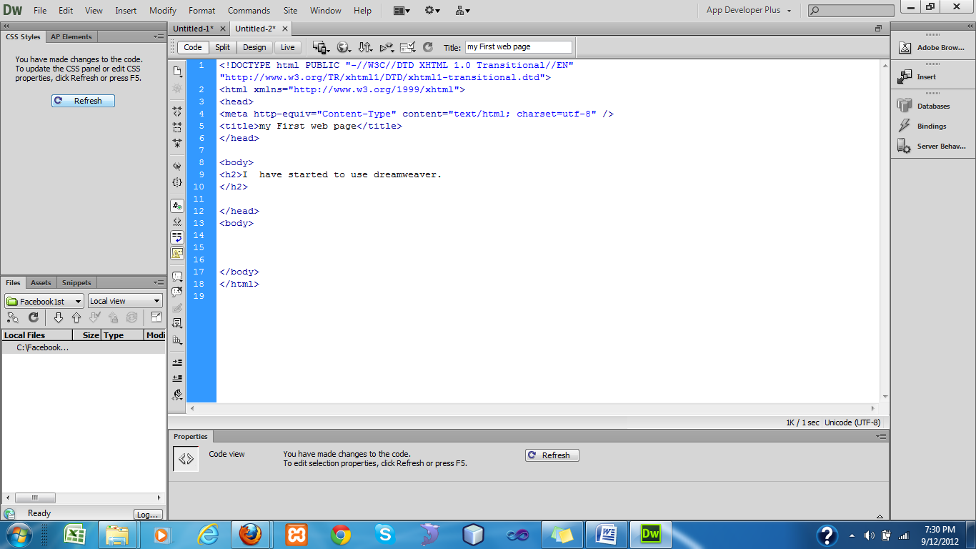

9. Try to track the changes in Design view.

## Building a new Website and managing pages in root folder

1. Open Dreamweaver CS6.
2. First of all go to **Site->New Site**, Create a Dreamweaver site and set the location of the root folder.
3. Declare the name of your site and set the location of the folder as shown in figure.

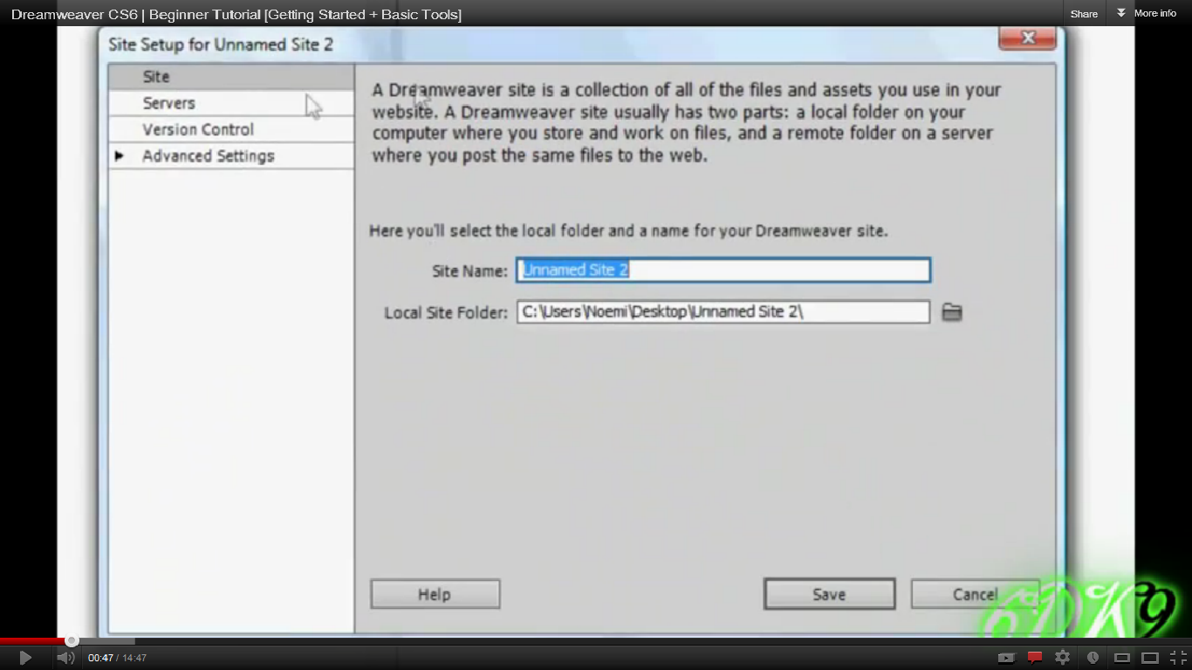

1. Go to **Window->File** to see the file panel. It keeps the root folder open to work on it as shown in figure.

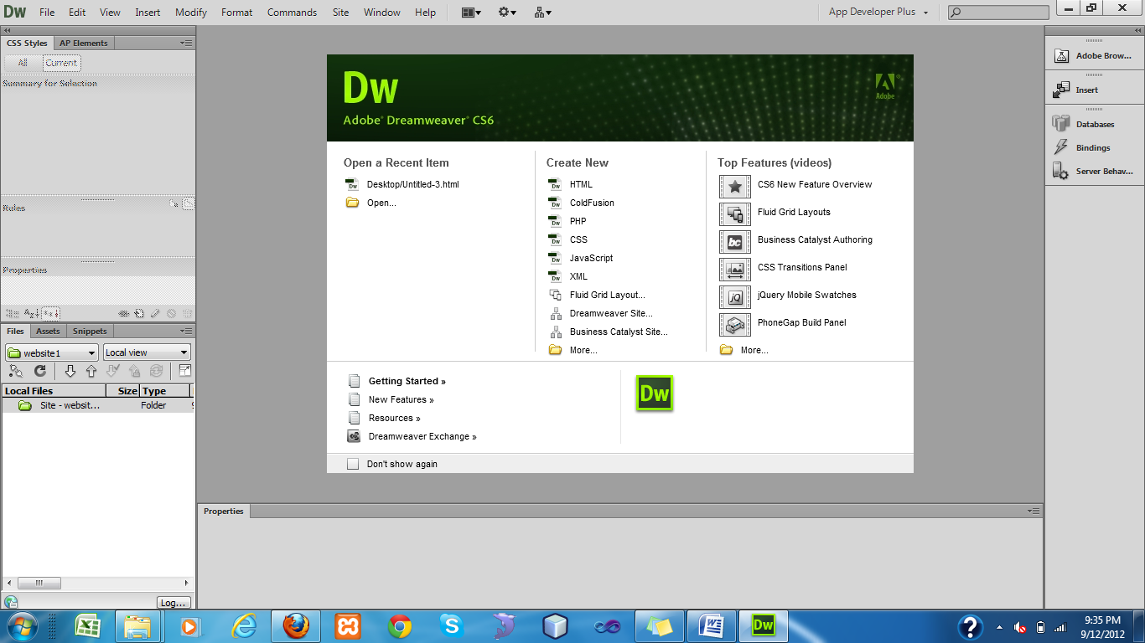

1. **File->New** Create a new HTM File and add it to the root folder. Your File Panel will show you the details of your website.
2. That is how you can manage your site in a root folder.

# HTML Introduction

## What is HTML?

HTML is the standard markup language for creating Web pages.

* HTML stands for Hyper Text Markup Language
* HTML describes the structure of Web pages using markup
* HTML elements are the building blocks of HTML pages
* HTML elements are represented by tags
* HTML tags label pieces of content such as "heading", "paragraph", "table", and so on
* Browsers do not display the HTML tags, but use them to render the content of the page

## A Simple HTML Document

### Example

<!DOCTYPE html>  
<html>  
<head>  
<title>Page Title</title>  
</head>  
<body>  
  
<h1>My First Heading</h1>  
<p>My first paragraph.</p>  
  
</body>  
</html>

[Try it Yourself »](https://www.w3schools.com/html/tryit.asp?filename=tryhtml_intro)

### Example Explained

* The <!DOCTYPE html> declaration defines this document to be HTML5
* The <html> element is the root element of an HTML page
* The <head> element contains meta information about the document
* The <title> element specifies a title for the document
* The <body> element contains the visible page content
* The <h1> element defines a large heading
* The <p> element defines a paragraph

## HTML Tags

HTML tags are element names surrounded by angle brackets:

<tagname>content goes here...</tagname>

* HTML tags normally come **in pairs** like <p> and </p>
* The first tag in a pair is the **start tag,** the second tag is the **end tag**
* The end tag is written like the start tag, but with a **forward slash** inserted before the tag name

**Tip:** The start tag is also called the **opening tag**, and the end tag the **closing tag**.

## Web Browsers

The purpose of a web browser (Chrome, IE, Firefox, Safari) is to read HTML documents and display them.

The browser does not display the HTML tags, but uses them to determine how to display the document:

## HTML Page Structure

Below is a visualization of an HTML page structure:

<html>

<head>

<title>Page title</title>

</head>

<body>

<h1>This is a heading</h1>

<p>This is a paragraph.</p>

<p>This is another paragraph.</p>

</body>

</html>

**Note:** Only the content inside the <body> section (the white area above) is displayed in a browser.

## The <!DOCTYPE> Declaration

The <!DOCTYPE> declaration represents the document type, and helps browsers to display web pages correctly.

It must only appear once, at the top of the page (before any HTML tags).

The <!DOCTYPE> declaration is not case sensitive.

The <!DOCTYPE> declaration for HTML is:

<!DOCTYPE html>

## Write HTML Using Notepad or TextEdit

Web pages can be created and modified by using professional HTML editors.

However, for learning HTML we recommend a simple text editor like Notepad (PC) or TextEdit (Mac).

We believe using a simple text editor is a good way to learn HTML.

Follow the four steps below to create your first web page with Notepad or TextEdit.

## Step 1: Open Notepad (PC)

**Windows 8 or later:**

Open the **Start Screen** (the window symbol at the bottom left on your screen). Type **Notepad**.

**Windows 7 or earlier:**

Open **Start** >**Programs >** **Accessories >** **Notepad**

## Step 1: Open TextEdit (Mac)

Open **Finder > Applications > TextEdit**

Also change some preferences to get the application to save files correctly. In **Preferences > Format >**choose**"Plain Text"**

Then under "Open and Save", check the box that says "Ignore rich text commands in HTML files".

**Then open a new document to place the code.**

## Step 2: Write Some HTML

Write or copy some HTML into Notepad.

<!DOCTYPE html>  
<html>  
<body>  
  
<h1>My First Heading</h1>  
  
<p>My first paragraph.</p>  
  
</body>  
</html>

## Step 3: Save the HTML Page

Save the file on your computer. Select **File > Save as** in the Notepad menu.

Name the file **"index.htm"** and set the encoding to **UTF-8** (which is the preferred encoding for HTML files).

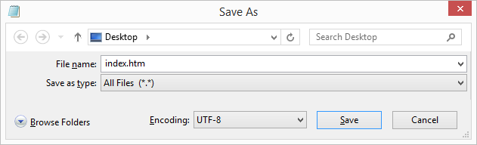

You can use either .htm or .html as file extension. There is no difference, it is up to you.

## Step 4: View the HTML Page in Your Browser

Open the saved HTML file in your favorite browser (double click on the file, or right-click - and choose "Open with").

The result will look much like this:

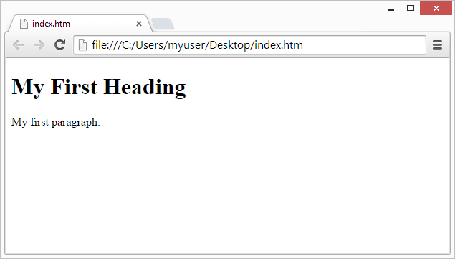

# HTML Basic Examples

## HTML Documents

All HTML documents must start with a document type declaration: **<!DOCTYPE html>**.

The HTML document itself begins with **<html>** and ends with **</html>**.

The visible part of the HTML document is between **<body>** and **</body>**.

### Example

<!DOCTYPE html>  
<html>  
<body>  
  
<h1>My First Heading</h1>  
<p>My first paragraph.</p>  
  
</body>  
</html>

[Try it Yourself »](https://www.w3schools.com/html/tryit.asp?filename=tryhtml_basic_document)

## HTML Headings

HTML headings are defined with the **<h1>** to **<h6>** tags.

<h1> defines the most important heading. <h6> defines the least important heading:

### Example

<h1>This is heading 1</h1>  
<h2>This is heading 2</h2>  
<h3>This is heading 3</h3>

[Try it Yourself »](https://www.w3schools.com/html/tryit.asp?filename=tryhtml_basic_headings)

## HTML Paragraphs

HTML paragraphs are defined with the **<p>** tag:

### Example

<p>This is a paragraph.</p>  
<p>This is another paragraph.</p>

[Try it Yourself »](https://www.w3schools.com/html/tryit.asp?filename=tryhtml_basic_paragraphs)

## HTML Links

HTML links are defined with the **<a>** tag:

### Example

<a href="https://www.w3schools.com">This is a link</a>

[Try it Yourself »](https://www.w3schools.com/html/tryit.asp?filename=tryhtml_basic_link)

The link's destination is specified in the **href attribute**.

Attributes are used to provide additional information about HTML elements.

## HTML Images

HTML images are defined with the **<img>** tag.

The source file (src), alternative text (alt), width, and height are provided as attributes:

### Example

<img src="w3schools.jpg" alt="W3Schools.com" width="104" height="142">

## HTML Elements

An HTML element usually consists of a **start** tag and **end** tag, with the content inserted in between:

<tagname>Content goes here...</tagname>

The HTML **element** is everything from the start tag to the end tag:

<p>My first paragraph.</p>

|  |  |  |
| --- | --- | --- |
| **Start tag** | **Element content** | **End tag** |
| <h1> | My First Heading | </h1> |
| <p> | My first paragraph. | </p> |
| <br> |  |  |

HTML elements with no content are called empty elements. Empty elements do not have an end tag, such as the <br> element (which indicates a line break).

## Nested HTML Elements

HTML elements can be nested (elements can contain elements).

All HTML documents consist of nested HTML elements.

This example contains four HTML elements:

### Example

<!DOCTYPE html>  
<html>  
<body>  
  
<h1>My First Heading</h1>  
<p>My first paragraph.</p>  
  
</body>  
</html>

[Try it Yourself »](https://www.w3schools.com/html/tryit.asp?filename=tryhtml_elements)

### Example Explained

The **<html>** element defines the **whole document**.

It has a **start** tag <html> and an **end** tag </html>.

The element **content** is another HTML element (the <body> element).

<html>  
<body>  
  
<h1>My First Heading</h1>  
<p>My first paragraph.</p>  
  
</body>  
</html>

The **<body>** element defines the **document body**.

It has a **start** tag <body> and an **end** tag </body>.

The element **content** is two other HTML elements (<h1> and <p>).

<body>  
  
<h1>My First Heading</h1>  
<p>My first paragraph.</p>  
  
</body>

The **<h1>** element defines a **heading**.

It has a **start** tag <h1> and an **end** tag </h1>.

The element **content** is: My First Heading.

<h1>My First Heading</h1>

The **<p>** element defines a **paragraph**.

It has a **start** tag <p> and an **end** tag </p>.

The element **content** is: My first paragraph.

<p>My first paragraph.</p>

## Do Not Forget the End Tag

Some HTML elements will display correctly, even if you forget the end tag:

### Example

<html>  
<body>  
  
<p>This is a paragraph  
<p>This is a paragraph  
  
</body>  
</html>

## HTML Attributes

* All HTML elements can have **attributes**
* Attributes provide **additional information** about an element
* Attributes are always specified in **the start tag**
* Attributes usually come in name/value pairs like: **name="value"**

## The lang Attribute

The language of the document can be declared in the **<html>** tag.

The language is declared with the **lang** attribute.

Declaring a language is important for accessibility applications (screen readers) and search engines:

<!DOCTYPE html>  
<html lang="en-US">  
<body>  
  
...  
  
</body>  
</html>

The first two letters specify the language (en). If there is a dialect, use two more letters (US).

## The title Attribute

Here, a **title** attribute is added to the **<p>** element. The value of the title attribute will be displayed as a tooltip when you mouse over the paragraph:

### Example

<p title="I'm a tooltip">  
This is a paragraph.  
</p>

[Try it Yourself »](https://www.w3schools.com/html/tryit.asp?filename=tryhtml_attributes_title)

## The href Attribute

HTML links are defined with the **<a>** tag. The link address is specified in the **href** attribute:

### Example

<a href="https://www.w3schools.com">This is a link</a>

[Try it Yourself »](https://www.w3schools.com/html/tryit.asp?filename=tryhtml_attributes_link)

You will learn more about links and the <a> tag later in this tutorial.

## Size Attributes

HTML images are defined with the **<img>** tag.

The filename of the source (**src**), and the size of the image (**width** and **height**) are all provided as **attributes**:

### Example

<img src="w3schools.jpg" width="104" height="142">

[Try it Yourself »](https://www.w3schools.com/html/tryit.asp?filename=tryhtml_attributes_img)

The image size is specified in pixels: width="104" means 104 screen pixels wide.

You will learn more about images and the <img> tag later in this tutorial.

## The alt Attribute

The **alt** attribute specifies an alternative text to be used, when an image cannot be displayed.

The value of the attribute can be read by screen readers. This way, someone "listening" to the webpage, e.g. a blind person, can "hear" the element.

### Example

<img src="w3schools.jpg" alt="W3Schools.com" width="104" height="142">

## HTML Links - Hyperlinks

HTML links are hyperlinks.

You can click on a link and jump to another document.

When you move the mouse over a link, the mouse arrow will turn into a little hand.

**Note:** A link does not have to be text. It can be an image or any other HTML element.

## HTML Links - Syntax

In HTML, links are defined with the **<a>** tag:

<a href="*url*">*link text*</a>

### Example

<a href="https://www.w3schools.com/html/">Visit our HTML tutorial</a>

[Try it Yourself »](https://www.w3schools.com/html/tryit.asp?filename=tryhtml_links_w3schools)

The **href** attribute specifies the destination address (https://www.w3schools.com/html/) of the link.

The **link text** is the visible part (Visit our HTML tutorial).

Clicking on the link text will send you to the specified address.

**Note:** Without a forward slash on subfolder addresses, you might generate two requests to the server. Many servers will automatically add a forward slash to the address, and then create a new request.

## Local Links

The example above used an absolute URL (A full web address).

A local link (link to the same web site) is specified with a relative URL (without http://www....).

### Example

<a href="html_images.asp">HTML Images</a>

[Try it Yourself »](https://www.w3schools.com/html/tryit.asp?filename=tryhtml_links)

## HTML Link Colors

By default, a link will appear like this (in all browsers):

* An unvisited link is underlined and blue
* A visited link is underlined and purple
* An active link is underlined and red

You can change the default colors, by using styles:

### Example

<style>  
a:link    {color:green; background-color:transparent; text-decoration:none}  
a:visited {color:pink; background-color:transparent; text-decoration:none}  
a:hover   {color:red; background-color:transparent; text-decoration:underline}  
a:active  {color:yellow; background-color:transparent; text-decoration:underline}  
</style>

[Try it Yourself »](https://www.w3schools.com/html/tryit.asp?filename=tryhtml_links_colors)

## HTML Links - The target Attribute

The **target** attribute specifies where to open the linked document.

The target attribute can have one of the following values:

* _blank - Opens the linked document in a new window or tab
* _self - Opens the linked document in the same window/tab as it was clicked (this is default)
* _parent - Opens the linked document in the parent frame
* _top - Opens the linked document in the full body of the window
* framename - Opens the linked document in a named frame

This example will open the linked document in a new browser window/tab:

### Example

<a href="https://www.w3schools.com/" target="_blank">Visit W3Schools!</a>

[Try it Yourself »](https://www.w3schools.com/html/tryit.asp?filename=tryhtml_links_target)

**Tip:** If your webpage is locked in a frame, you can use target="_top" to break out of the frame:

### Example

<a href="https://www.w3schools.com/html/" target="_top">HTML5 tutorial!</a>

[Try it Yourself »](https://www.w3schools.com/html/tryit.asp?filename=tryhtml_links_target_top)

## HTML Links - Image as Link

It is common to use images as links:

### Example

<a href="default.asp">  
  <img src="smiley.gif" alt="HTML tutorial" style="width:42px;height:42px;border:0;">  
</a>

[Try it Yourself »](https://www.w3schools.com/html/tryit.asp?filename=tryhtml_links_image)

**Note:** border:0; is added to prevent IE9 (and earlier) from displaying a border around the image (when the image is a link).

## HTML Links - Create a Bookmark

HTML bookmarks are used to allow readers to jump to specific parts of a Web page.

Bookmarks can be useful if your webpage is very long.

To make a bookmark, you must first create the bookmark, and then add a link to it.

When the link is clicked, the page will scroll to the location with the bookmark.

## Example

First, create a bookmark with the id attribute:

<h2 id="tips">Useful Tips Section</h2>

Then, add a link to the bookmark ("Useful Tips Section"), from within the same page:

<a href="#tips">Visit the Useful Tips Section</a>

Or, add a link to the bookmark ("Useful Tips Section"), from another page:

### Example

<a href="html_tips.html#tips">Visit the Useful Tips Section</a>

[Try it Yourself »](https://www.w3schools.com/html/tryit.asp?filename=tryhtml_links_bookmark)

## External Paths

External pages can be referenced with a full URL or with a path relative to the current web page.

This example uses a full URL to link to a web page:

### Example

<a href="https://www.w3schools.com/html/default.asp">HTML tutorial</a>

[Try it Yourself »](https://www.w3schools.com/html/tryit.asp?filename=tryhtml_links_external_url)

This example links to a page located in the html folder on the current web site:

### Example

<a href="/html/default.asp">HTML tutorial</a>

[Try it Yourself »](https://www.w3schools.com/html/tryit.asp?filename=tryhtml_links_external_relative)

This example links to a page located in the same folder as the current page:

### Example

<a href="default.asp">HTML tutorial</a>

# HTML Images

## JPG Images

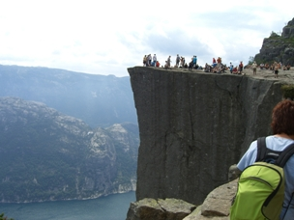

## GIF Images



## PNG Images

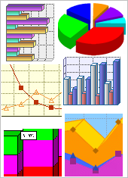

### Example

<!DOCTYPE html>  
<html>  
<body>  
  
<h2>Spectacular Mountain</h2>  
<img src="pic_mountain.jpg" alt="Mountain View" style="width:304px;height:228px;">  
  
</body>  
</html>

[Try it Yourself »](https://www.w3schools.com/html/tryit.asp?filename=tryhtml_images_mountain)

## HTML Images Syntax

In HTML, images are defined with the **<img>** tag.

The <img> tag is empty, it contains attributes only, and does not have a closing tag.

The src attribute specifies the URL (web address) of the image:

<img src="*url*" alt="*some_text*" style="width:width;height:height;">

## The alt Attribute

The alt attribute provides an alternate text for an image, if the user for some reason cannot view it (because of slow connection, an error in the src attribute, or if the user uses a screen reader).

If a browser cannot find an image, it will display the value of the alt attribute:

### Example

<img src="wrongname.gif" alt="HTML5 Icon" style="width:128px;height:128px;">

[Try it Yourself »](https://www.w3schools.com/html/tryit.asp?filename=tryhtml_images_wrong)

The alt attribute is required. A web page will not validate correctly without it.

## HTML Screen Readers

A screen reader is a software program that reads the HTML code, converts the text, and allows the user to "listen" to the content. Screen readers are useful for people who are blind, visually impaired, or learning disabled.

## Image Size - Width and Height

You can use the **style** attribute to specify the width and height of an image.

The values are specified in pixels (use px after the value):

### Example

<img src="html5.gif" alt="HTML5 Icon" style="width:128px;height:128px;">

[Try it Yourself »](https://www.w3schools.com/html/tryit.asp?filename=tryhtml_images_size)

Alternatively, you can use the **width** and **height** attributes. Here, the values are specified in pixels by default:

### Example

<img src="html5.gif" alt="HTML5 Icon" width="128" height="128">

[Try it Yourself »](https://www.w3schools.com/html/tryit.asp?filename=tryhtml_images_attributes)

**Note:** Always specify the width and height of an image. If width and height are not specified, the page will flicker while the image loads.

## Width and Height, or Style?

Both the width, height, and style attributes are valid in HTML5.

However, we suggest using the style attribute. It prevents internal or external styles sheets from changing the original size of images:

### Example

<!DOCTYPE html>  
<html>  
<head>  
<style>  
img {   
    width:100%;   
}  
</style>  
</head>  
<body>  
  
<img src="html5.gif" alt="HTML5 Icon" style="width:128px;height:128px;">  
<img src="html5.gif" alt="HTML5 Icon" width="128" height="128">  
  
</body>  
</html>

[Try it Yourself »](https://www.w3schools.com/html/tryit.asp?filename=tryhtml_images_style)

## Images in Another Folder

If not specified, the browser expects to find the image in the same folder as the web page.

However, it is common to store images in a sub-folder. You must then include the folder name in the src attribute:

### Example

<img src="/images/html5.gif" alt="HTML5 Icon" style="width:128px;height:128px;">

[Try it Yourself »](https://www.w3schools.com/html/tryit.asp?filename=tryhtml_images_folder)

## Images on Another Server

Some web sites store their images on image servers.

Actually, you can access images from any web address in the world:

### Example

<img src="https://www.w3schools.com/images/w3schools_green.jpg" alt="W3Schools.com">

[Try it Yourself »](https://www.w3schools.com/html/tryit.asp?filename=tryhtml_images_w3schools)

You can read more about file paths in the chapter [HTML File Paths](https://www.w3schools.com/html/html_filepaths.asp).

## Animated Images

The GIF standard allows animated images:

### Example

<img src="programming.gif" alt="Computer Man" style="width:48px;height:48px;">

[Try it Yourself »](https://www.w3schools.com/html/tryit.asp?filename=tryhtml_images_hackman)

Note that the syntax of inserting animated images is no different from non-animated images.

## Using an Image as a Link

 To use an image as a link, simply nest the <img> tag inside the <a> tag:

### Example

<a href="default.asp">  
  <img src="smiley.gif" alt="HTML tutorial" style="width:42px;height:42px;border:0;">  
</a>

[Try it Yourself »](https://www.w3schools.com/html/tryit.asp?filename=tryhtml_images_link)

**Note:** border:0; is added to prevent IE9 (and earlier) from displaying a border around the image (when the image is a link).

## Image Floating

Use the CSS **float** property to let the image float to the right or to the left of a text:

### Example

<p><img src="smiley.gif" alt="Smiley face" style="float:right;width:42px;height:42px;">  
The image will float to the right of the text.</p>  
  
<p><img src="smiley.gif" alt="Smiley face" style="float:left;width:42px;height:42px;">  
The image will float to the left of the text.</p>

[Try it Yourself »](https://www.w3schools.com/html/tryit.asp?filename=tryhtml_images_float)

## Image Maps

Use the <map> tag to define an image-map. An image-map is an image with clickable areas.

The name attribute of the <map> tag is associated with the <img>'s usemap attribute and creates a relationship between the image and the map.

The <map> tag contains a number of <area> tags, that defines the clickable areas in the image-map:

### Example

<img src="planets.gif" alt="Planets" usemap="#planetmap" style="width:145px;height:126px;">  
  
<map name="planetmap">  
  <area shape="rect" coords="0,0,82,126" alt="Sun" href="sun.htm">  
  <area shape="circle" coords="90,58,3" alt="Mercury" href="mercur.htm">  
  <area shape="circle" coords="124,58,8" alt="Venus" href="venus.htm">  
</map>

# HTML Tables

### HTML Table Example

|  |  |  |
| --- | --- | --- |
| **Company** | **Contact** | **Country** |
| Alfreds Futterkiste | Maria Anders | Germany |
| Centro comercial Moctezuma | Francisco Chang | Mexico |
| Ernst Handel | Roland Mendel | Austria |
| Island Trading | Helen Bennett | UK |
| Laughing Bacchus Winecellars | Yoshi Tannamuri | Canada |
| Magazzini Alimentari Riuniti | Giovanni Rovelli | Italy |

[Try it Yourself »](https://www.w3schools.com/html/tryit.asp?filename=tryhtml_table_intro)

## Defining an HTML Table

An HTML table is defined with the **<table>** tag.

Each table row is defined with the **<tr>** tag. A table header is defined with the **<th>** tag. By default, table headings are bold and centered. A table data/cell is defined with the **<td>** tag.

### Example

<table style="width:100%">  
  <tr>  
    <th>Firstname</th>  
    <th>Lastname</th>   
    <th>Age</th>  
  </tr>  
  <tr>  
    <td>Jill</td>  
    <td>Smith</td>   
    <td>50</td>  
  </tr>  
  <tr>  
    <td>Eve</td>  
    <td>Jackson</td>   
    <td>94</td>  
  </tr>  
</table>

[Try it Yourself »](https://www.w3schools.com/html/tryit.asp?filename=tryhtml_table)

**Note:** The <td> elements are the data containers of the table.  
They can contain all sorts of HTML elements; text, images, lists, other tables, etc.

## HTML Table - Adding a Border

If you do not specify a border for the table, it will be displayed without borders.

A border is set using the CSS **border** property:

### Example

table, th, td {  
    border: 1px solid black;  
}

[Try it Yourself »](https://www.w3schools.com/html/tryit.asp?filename=tryhtml_table_border)

Remember to define borders for both the table and the table cells.

## HTML Table - Collapsed Borders

If you want the borders to collapse into one border, add the CSS **border-collapse** property:

### Example

table, th, td {  
    border: 1px solid black;  
    border-collapse: collapse;  
}

[Try it Yourself »](https://www.w3schools.com/html/tryit.asp?filename=tryhtml_table_collapse)

## HTML Table - Adding Cell Padding

Cell padding specifies the space between the cell content and its borders.

If you do not specify a padding, the table cells will be displayed without padding.

To set the padding, use the CSS **padding** property:

### Example

th, td {  
    padding: 15px;  
}

[Try it Yourself »](https://www.w3schools.com/html/tryit.asp?filename=tryhtml_table_cellpadding)

## HTML Table - Left-align Headings

By default, table headings are bold and centered.

To left-align the table headings, use the CSS **text-align** property:

### Example

th {  
    text-align: left;  
}

[Try it Yourself »](https://www.w3schools.com/html/tryit.asp?filename=tryhtml_table_headings_left)

## HTML Table - Adding Border Spacing

Border spacing specifies the space between the cells.

To set the border spacing for a table, use the CSS **border-spacing** property:

### Example

table {  
    border-spacing: 5px;  
}

[Try it Yourself »](https://www.w3schools.com/html/tryit.asp?filename=tryhtml_table_cellspacing)

**Note:** If the table has collapsed borders, border-spacing has no effect.

## HTML Table - Cells that Span Many Columns

To make a cell span more than one column, use the **colspan** attribute:

### Example

<table style="width:100%">  
  <tr>  
    <th>Name</th>  
    <th colspan="2">Telephone</th>  
  </tr>  
  <tr>  
    <td>Bill Gates</td>  
    <td>55577854</td>  
    <td>55577855</td>  
  </tr>  
</table>

[Try it Yourself »](https://www.w3schools.com/html/tryit.asp?filename=tryhtml_table_colspan)

## HTML Table - Cells that Span Many Rows

To make a cell span more than one row, use the **rowspan** attribute:

### Example

<table style="width:100%">  
  <tr>  
    <th>Name:</th>  
    <td>Bill Gates</td>  
  </tr>  
  <tr>  
    <th rowspan="2">Telephone:</th>  
    <td>55577854</td>  
  </tr>  
  <tr>  
    <td>55577855</td>  
  </tr>  
</table>

[Try it Yourself »](https://www.w3schools.com/html/tryit.asp?filename=tryhtml_table_rowspan)

## HTML Table - Adding a Caption

To add a caption to a table, use the **<caption>** tag:

### Example

<table style="width:100%">  
  <caption>Monthly savings</caption>  
  <tr>  
    <th>Month</th>  
    <th>Savings</th>  
  </tr>  
  <tr>  
    <td>January</td>  
    <td>$100</td>  
  </tr>  
  <tr>  
    <td>February</td>  
    <td>$50</td>  
  </tr>  
</table>

[Try it Yourself »](https://www.w3schools.com/html/tryit.asp?filename=tryhtml_tables2)

**Note:** The <caption> tag must be inserted immediately after the <table> tag.

## A Special Style for One Table

To define a special style for a special table, add an **id** attribute to the table:

### Example

<table id="t01">  
  <tr>  
    <th>Firstname</th>  
    <th>Lastname</th>   
    <th>Age</th>  
  </tr>  
  <tr>  
    <td>Eve</td>  
    <td>Jackson</td>   
    <td>94</td>  
  </tr>  
</table>

### Now you can define a special style for this table:

table#t01 {  
    width: 100%;   
    background-color: #f1f1c1;  
}

[Try it Yourself »](https://www.w3schools.com/html/tryit.asp?filename=tryhtml_table_id1)

### And add more styles:

table#t01 tr:nth-child(even) {  
    background-color: #eee;  
}  
table#t01 tr:nth-child(odd) {  
    background-color: #fff;  
}  
table#t01 th {  
    color: white;  
    background-color: black;  
}

# Frameset

### Example

A simple three-framed page:

<frameset cols="25%,*,25%">  
  <frame src="frame_a.htm">  
  <frame src="frame_b.htm">  
  <frame src="frame_c.htm">  
</frameset>

[Try it Yourself »](https://www.w3schools.com/tags/tryit.asp?filename=tryhtml_frame_cols)

More "Try it Yourself" examples below.

## Definition and Usage

The <frameset> tag is not supported in HTML5.

The <frameset> tag defines a frameset.

The <frameset> element holds one or more [<frame>](https://www.w3schools.com/tags/tag_frame.asp) elements. Each <frame> element can hold a separate document.

The <frameset> element specifies HOW MANY columns or rows there will be in the frameset, and HOW MUCH percentage/pixels of space will occupy each of them.

**Note:** If you want to validate a page containing frames, be sure the [<!DOCTYPE>](https://www.w3schools.com/tags/tag_doctype.asp) is set to either "HTML Frameset DTD" or "XHTML Frameset DTD".

# HTML Iframes

An iframe is used to display a web page within a web page.

## Iframe Syntax

An HTML iframe is defined with the **<iframe>** tag:

<iframe src="URL"></iframe>

The **src** attribute specifies the URL (web address) of the inline frame page.

## Iframe - Set Height and Width

Use the **height** and **width** attributes to specify the size of the iframe.

The attribute values are specified in pixels by default, but they can also be in percent (like "80%").

### Example

<iframe src="demo_iframe.htm" height="200" width="300"></iframe>

[Try it Yourself »](https://www.w3schools.com/html/tryit.asp?filename=tryhtml_iframe_height_width)

## Iframe - Remove the Border

By default, an iframe has a border around it.

To remove the border, add the **style** attribute and use the CSS **border** property:

### Example

<iframe src="demo_iframe.htm" style="border:none;"></iframe>

[Try it Yourself »](https://www.w3schools.com/html/tryit.asp?filename=tryhtml_iframe_frameborder)

With CSS, you can also change the size, style and color of the iframe's border:

### Example

<iframe src="demo_iframe.htm" style="border:2px solid grey;"></iframe>

[Try it Yourself »](https://www.w3schools.com/html/tryit.asp?filename=tryhtml_iframe_border2)

## Iframe - Target for a Link

An iframe can be used as the target frame for a link.

The **target** attribute of the link must refer to the **name** attribute of the iframe:

### Example

<iframe src="demo_iframe.htm" name="iframe_a"></iframe>  
  
<p><a href="https://www.w3schools.com" target="iframe_a">W3Schools.com</a></p>

# Lab Tasks

## Task A

* Update the skeleton HTML5 page and create your own portfolio.

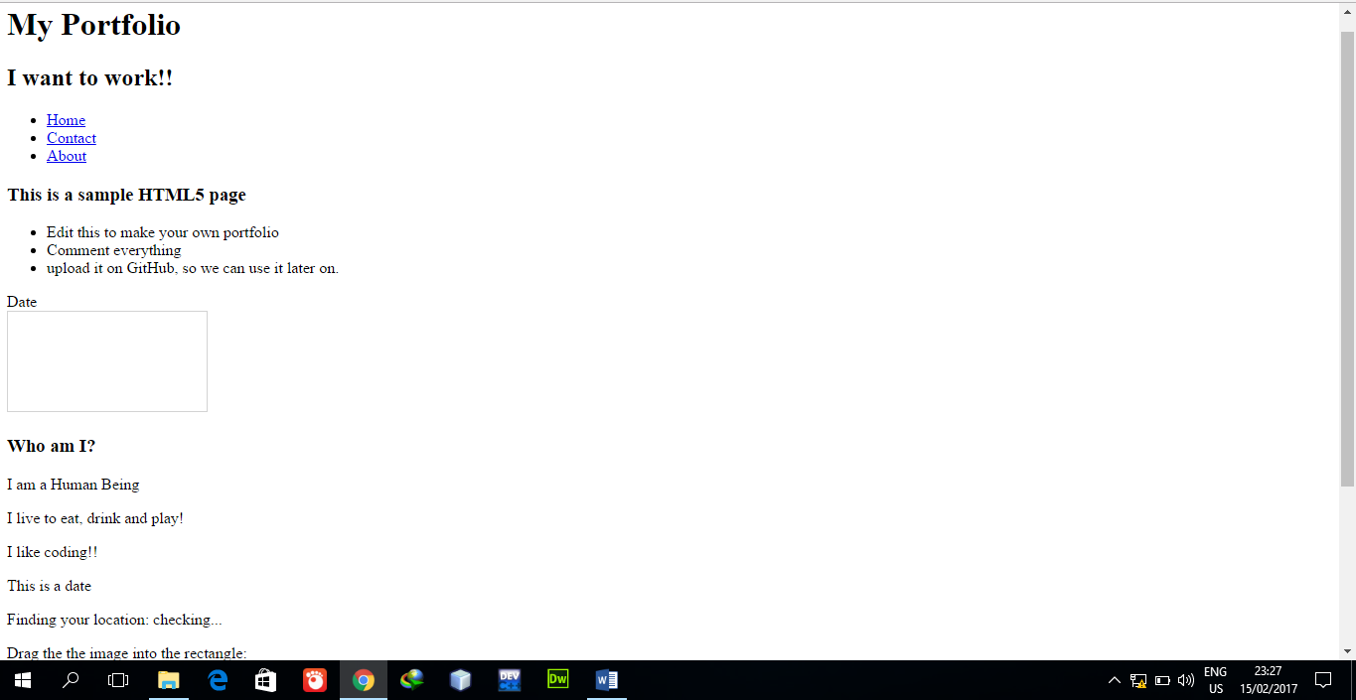

* The Title of page should be your Name.
* Sections: Home, About, Gallery, Contact Me (Create different pages and use anchor tag to create hyperlink)
* Gallery should be a separate Web pages showing pictures of the individual
* The remaining sections should be on the same page where they can be reached by clicking on the anchor name listed at the top

## Lab Task B

Create the following table

|  |  |  |
| --- | --- | --- |
| **Lab Task B** | | |
| **Name** | **Subject** | **Interest** |
| Osama | Web Engineering | Facebook thumbs up image clipart |
| Fatima |

## Lab Task C

* Create a frameset based on the following format

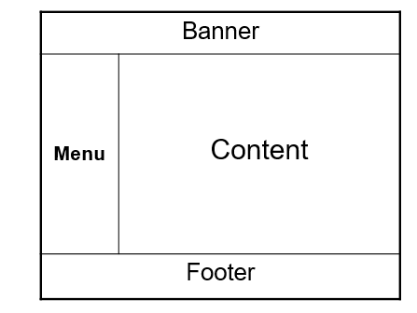

* The banner should include a HTML document showing NUST-SEECS logo
* Footer mentions contact details, copyright, address and other details
* Menu contains an HTML document should 3 hyperlinks named Google, Yahoo and MSN
* Clicking on a specific link should load the designated search engine onto the content frame. (Hint: Use target attribute of hyperlink tag for this task)

## Lab Task D

Achieve the same task mentioned in Lab Task C but using iFrames instead